TCR INNOVTION
MACHINE LEARNING WITH PYTHON
Name : Sumit Santosh Gawande
Batch : Machine Learning EEWith Python
Project Name : Prediction Of Heart Disease
Certificate code = TCRIG02R03
Group = OWN

import numpy as np
import pandas as pd
import seaborn as sns
import matplotlib.pyplot as plt
from matplotlib import rcParams
from matplotlib.cm import rainbow
%matplotlib inline
import warnings
warnings.filterwarnings('ignore')
from sklearn.model_selection import train_test_split
from sklearn.linear_model import LogisticRegression
from sklearn.preprocessing import StandardScaler
from sklearn.metrics import accuracy_score
from sklearn.metrics import confusion_matrix

DATA COLLECTION AND PROCESSING
heart_data = pd.read_csv('/content/heart.csv')

#print first 5 rows of the dataset
heart_data.head()
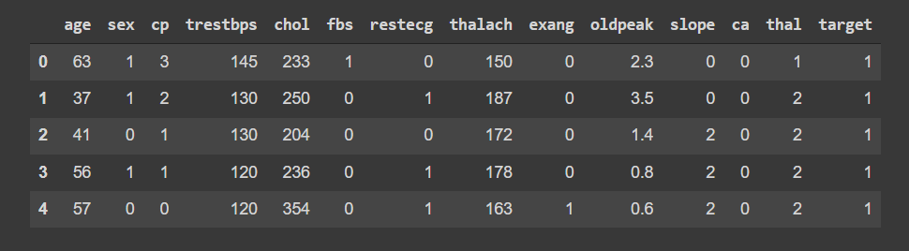
heart_data.shape

(303, 14)
#defining columns
heart_data.columns

Index(['age', 'sex', 'cp', 'trestbps', 'chol', 'fbs', 'restecg', 'thalach', 'exang', 'oldpeak', 'slope', 'ca', 'thal', 'target'],
dtype='object')
#some info about the data
heart_data.info()

<class 'pandas.core.frame.DataFrame'>
RangeIndex: 303 entries, 0 to 302
Data columns (total 14 columns):
# Column Non-Null Count Dtype
--- ------ -------------- -----
0 age 303 non-null int64
1 sex 303 non-null int64
2 cp 303 non-null int64
3 trestbps 303 non-null int64
4 chol 303 non-null int64
5 fbs 303 non-null int64
6 restecg 303 non-null int64
7 thalach 303 non-null int64
8 exang 303 non-null int64
9 oldpeak 303 non-null float64
10 slope 303 non-null int64
11 ca 303 non-null int64
12 thal 303 non-null int64
13 target 303 non-null int64
dtypes: float64(1), int64(13)
memory usage: 33.3 KB

#statistical measure about the data
heart_data.describe()

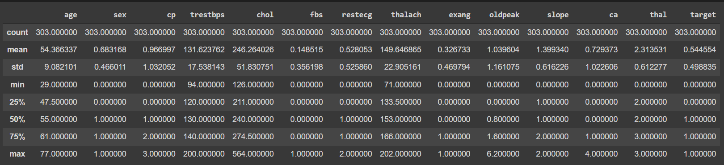

CHECKING FOR MISSING VALUES IN DATASE

heart_data.isnull().sum()

age 0
sex 0
cp 0
trestbps 0
chol 0
fbs 0
restecg 0
thalach 0
exang 0
oldpeak 0
slope 0
ca 0
thal 0
target 0
dtype: int64

#checking the distribution of Target Variable
heart_data['target'].value_counts()

1 165
0 138
Name: target, dtype: int64
165 are Heart disease cases 138 are non Heart disease cases

heart_data['sex'].value_counts()

1 207
0 96
Name: sex, dtype: int64
Hence, Males are 207 and Females are 96

*FINDING THE CORRELATIONS AMONG ATTRIBUTES IN DATASET *

plt.figure(figsize=(20,15))
sns.heatmap(heart_data.corr(), annot= True, cmap='RdYlGn')
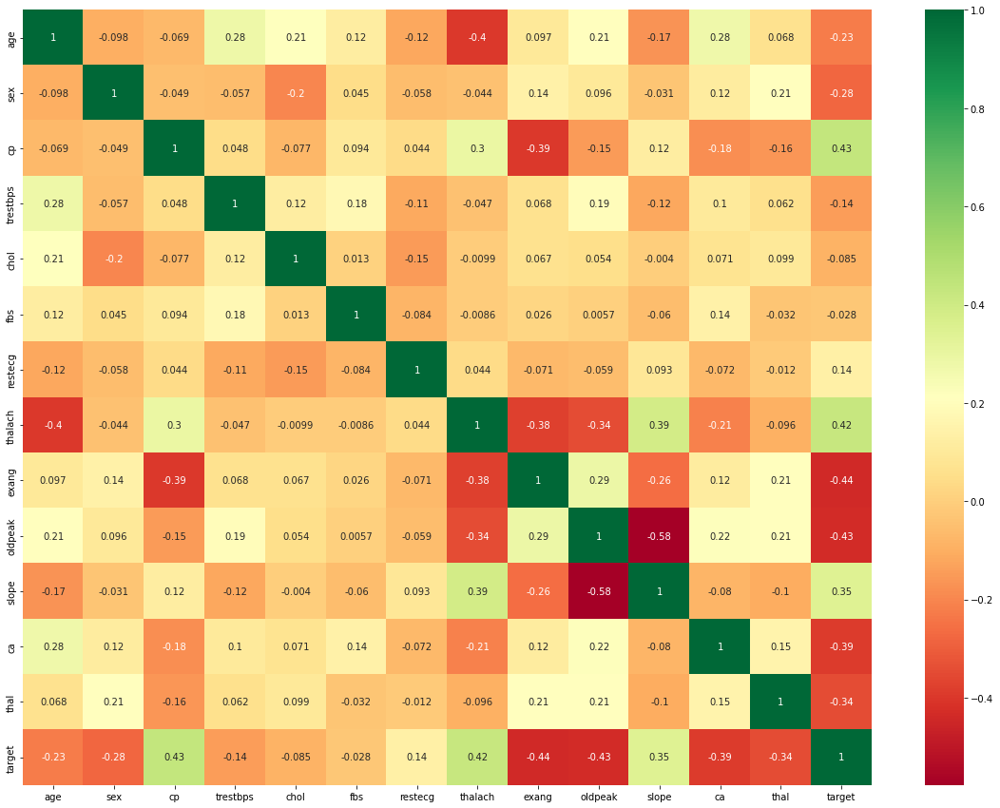

*HISTOGRAMS OF THE GIVEN DATA *
heart_data.hist(figsize=(30,40), layout=(9,7));

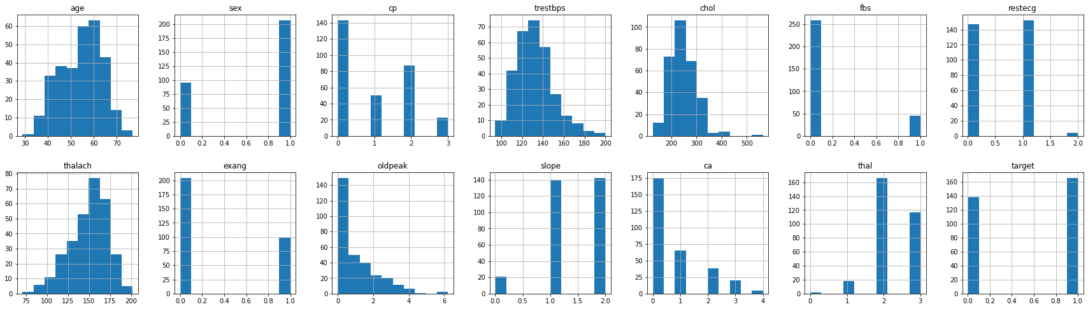

#only for target column
sns.countplot(x='target',palette='BuPu', data=heart_data)

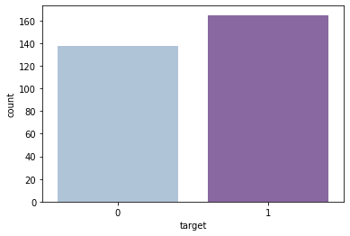
SCALING THE DATA
StandardScaler = StandardScaler()
columns_to_scale = ['age','trestbps','chol','thalach','oldpeak']
heart_data[columns_to_scale] = StandardScaler.fit_transform(heart_data[columns_to_scale])

heart_data.head()

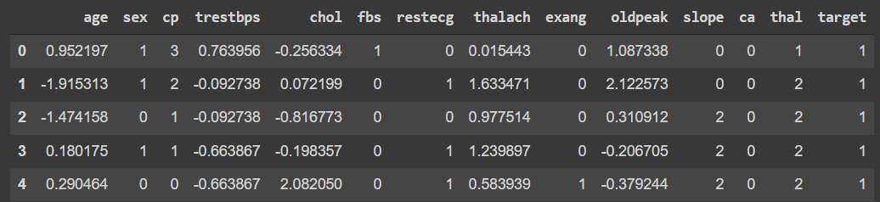

SPLITTING THE FEATURES AND TARGET

X = heart_data.drop(columns = 'target', axis = 1)
Y = heart_data['target']

print(X)

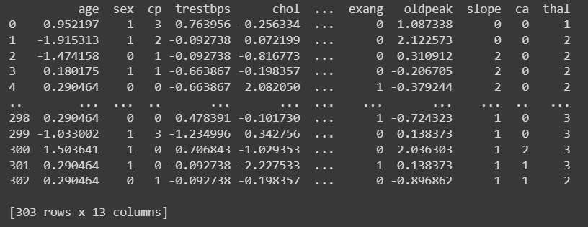

print(Y)

0 1
1 1
2 1
3 1
4 1
..
298 0
299 0
300 0
301 0
302 0
Name: target, Length: 303, dtype: int64

SPLITTING THE DATA INTO TRAINING DATA AND TEST DATA
X_train , X_test , Y_train , Y_test = train_test_split(X,Y,test_size=0.3, random_state= 40)
print('X_train-',X_train.size)
print('X_test-',X_test.size)
print('Y_train-',Y_train.size)
print('Y_test-',Y_test.size)

X_train- 2756
X_test- 1183
Y_train- 212
Y_test- 91
print(X.shape, X_train.shape, X_test.shape)

(303, 13) (212, 13) (91, 13)

** MODEL TRAINING**
** LOGISTIC REGRESSION**

lr= LogisticRegression()

model1=lr.fit(X_train, Y_train)
prediction1=model1.predict(X_test)

CONFUSION MATRIX
cm=confusion_matrix(Y_test,prediction1)
cm

array([[36, 4],
[ 3, 48]])
sns.heatmap(cm, annot=True, cmap='seismic')

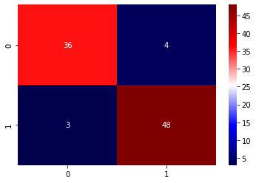

Here it shows that 36 cases are highly predictive by this algorithm

TESTING ACCURACY
TP=cm[0][0]
TN=cm[1][1]
FN=cm[1][0]
FP=cm[0][1]
print('Testing Accuracy:', (TP+TN)/(TP+TN+FN+FP))

Testing Accuracy: 0.9230769230769231

MODEL EVALUATION
ACCURACY SCORE

#Accuracy on training data
X_train_prediction = model.predict(X_train)
training_data_accuracy = accuracy_score(X_train_prediction, Y_train)

print("Accuracy on Training data : ", training_data_accuracy)

Accuracy on Training data : 0.8301886792452831
#Accuracy on test data
X_test_prediction = model.predict(X_test)
test_data_accuracy = accuracy_score(X_test_prediction, Y_test)

print("Accuracy on Test data : ", test_data_accuracy)

Accuracy on Test data : 0.9230769230769231

BUILDING A PREDICTIVE SYSTEM

input_data = (41,0,1,130,204,0,0,172,0,1.4,2,0,2)

#Changing the input data to a numpy array
input_data_as_numpy_array = np.asarray(input_data)

#Reshaping the numpy array for 1 instance
input_data_reshaped = input_data_as_numpy_array.reshape(1,-1)

prediction = model.predict(input_data_reshaped)
print(prediction)

if (prediction [0] == 0 ):
print("The Person does not have a Heart Disease")
else:
print("The Person has Heart Disease")

[1]
The Person has Heart Disease
/usr/local/lib/python3.7/dist-packages/sklearn/base.py:446: UserWarning: X does not have valid feature names, but LogisticRegression was fitted with feature names
"X does not have valid feature names, but"

- By SUMIT GAWANDE

